Charmaine Cheung

Trane Technologies - Finance RtR Intern

# What’s Next?

* Final year in National College of Ireland.
* This work placement has helped me to plan my future career path.
* Motivated to work hard and complete my final exams to get back to the workplace



# Conclusion

* Student with 12 months’ of invaluable work experience.
* Learned from working with industry professionals in a Multinational Company.
* An invaluable experience like no other.

# Trane Technologies vs. COVID-19 Pandemic

* In early 2020, Trane Technologies’ leadership team formed a dedicated worldwide task force to solidify the cold chain in preparation to transport the COVID vaccines with the Superfreezer.
* [SuperFreezer](https://www.thermoking.com/na/en/products.marine.refrigeration_units.superfreezer.html" \t "_blank) (Thermo King) provides transport and storage capability with an ultra-low set point of -70C.



# Company Background

* Trane Technologies is a global climate innovator, bringing efficient and sustainable climate solutions to buildings, homes and transportation.
* The company offers products from its main brands Trane and Thermo King.
* Trane Technologies provides customers with innovative products for commercial heating and cooling systems, building controls, heating and cooling for housing and much more.

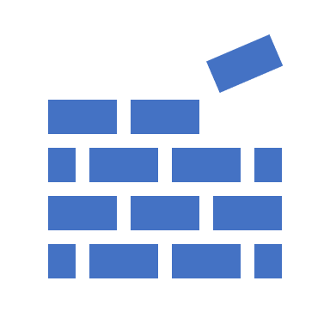

# Skills Devleloped:

* IT Skills
* General Business knowledge
* Independent Working Skills
* Analytical Skills
* Communication Skills



# Main Tasks

* Manual Billing
* Cash Forecast
* Assisted Revenue & Expense team in the month-end inventory closing
* Post journals from the SBU
* Process invoices for two Intercompany legal entities

# My Role

As a Finance RtR Intern I worked under three teams:

* Cash & Subledger
* Revenue & Expense
* Intercompany

